



Seminar Report on

**“ Project Loon : The Balloon-Powered Internet ”**

Submitted for partial fulfilment of requirement for the degree of

**BACHELOR OF ENGINEERING**

**IN**

**COMPUTER SCIENCE AND ENGINEERING**

Submitted By

**Manish Prakash Dhaye**

Under the Guidance of

**Prof. N. G. Rathi**



**Department of Computer Science and Engineering**

**(Accredited by NBA)**

**Sipna College of Engineering & Technology, Amravati.**

**(Accredited by NAAC with Grade ‘A+’)**

**Sant Gadge Baba Amravati University, Amravati**

**2024 – 2025**

**Sipna College of Engineering & Technology, Amravati.**

**Department of Computer science and Engineering**

**CERTIFICATE**

This is to certify that seminar entitled **Project Loon : Balloon-Powered Internet** is delivered and report is submitted by **Manish Prakash Dhaye** in **Semester : 7th** for partial fulfilment of requirement for the degree of BACHLORE OF ENGINEERING in **Computer Science** of Sant Gadge Baba Amravati University , Amravati during the academic year 2022-2023.

**Prof. N. G. Rathi**  **Dr. V. K. Shandilya**

Guide Head of Department

**Dr. S. M. Kherde**

Principal

**ACKNOWLEDGEMENT**

A moment of pause, to express a deep gratitude to several individuals, without whom this seminar could not have been completed. I feel immense pleasure to express deep sense of gratitude and indebtedness to our guide **Prof. N. G. Rathi** for constant encouragement and noble guidance.

I express our sincere thanks to **Dr. V. K. Shandilya**, Head, Department of Computer Science & Engineering and the other faculty members of the department for their kind co-operation.

I express my sincere thanks to **Dr. S. M. Kherde**, Principal, Sipna College of Engineering & Technology for his valuable guidance. I also express my sincere thanks to the library staff members of the college.

Last but not the least I am thankful to **our friends and parents** whose best wishes are always with me.

**Manish Prakash Dhaye**

**INDEX**

|  |  |  |
| --- | --- | --- |
| SERIAL  No. | CONTENT | PAGE No. |
| 1 | Introduction | 1 |
| 2 | History | 2 |
| 3 | Structure Of Balloon | 4 |
| 4 | Working Of Loon Technology | 6 |
| 5 | Connectivity Bet. Balloon & Ground | 8 |
| 6 | AI’s Role in Project Loon | 10 |
| 7 | Working Of DRL Through Example | 11 |
| 8 | Advantages of Project Loon | 13 |
| 9 | Limitations of Project Loon | 14 |
| 10 | Future scope of Project Loon | 15 |
| 11 | Conclusion | 16 |
| 12 | References | 17 |

**ABSTRACT**

The internet is like oxygen for every human being on this earth and still we do not have this internet for every human being. There are too many obstacles located on the earth. In most of the countries the cost of an Internet is not payable for most of the peoples. So to solve this problem today I am uncovering great loon shot from Google X: balloon-powered Internet access.

It is possible for us to create chain of balloons flying in stratosphere to provide internet in the some regions on earth.I hope this project loon could become a good option for providing internet connectivity to rural, remote, and mountain area This has no effect in case of natural disaster even if there is natural disaster the balloons will remain there for the purpose internet connection. The idea may sound a bit crazy-and that’s part of the reason it will called as Project Loon-but there’s a solid science behind it.

**Index Terms— Stratosphere, balloon etc .**

**INTRODUCTION**

**Loon LLC** was an **Alphabet Inc.** subsidiary working on providing Internet access to rural and remote areas. The company used high-altitude balloons in the stratosphere at an altitude of 18 km (11 mi) to 25 km (16 mi) to create an aerial wireless network with up to 1 Mbit/s speeds. A reference to the balloons used, **Project Loon** began as a research and development project by X (formerly Google X) in 2011, but later spun out into a separate company in July 2018. In January 2021, it was announced that the company would be temporarily discontinued due to lack of profitability.

The balloon network was designed for connecting the people, it travels on the edges of space. Through the network of balloons people in rural and remote areas are getting connected . These balloon structures are 15-meters wide and made from polyethylene film.

For this Google explained : *“Signals are transmitted through the project loon`s balloons to an specialized Internet antenna mounted at the workplace that use technology of radio frequency”. “The Internet antenna is connected to consumer grade router. Network signals that travel through the balloon are relayed to ground stations, where it’s connected to pre-existing internet infrastructure, like our local telecommunication infrastructure and Fiber optic cables.”*

**HISTORY**

* **Internal project and the public announcement**

Unofficial development on the project began in 2011 under incubation in [Google X](https://en.wikipedia.org/wiki/Google_X) with a series of trial runs in [California](https://en.wikipedia.org/wiki/California)'s [Central Valley](https://en.wikipedia.org/wiki/Central_Valley_(California)). The project was officially announced as a Google project **on June 14, 2013.**

* **First launch**

**On June 16, 2013,** Google launched about 30 balloons in [New Zealand](https://en.wikipedia.org/wiki/New_Zealand) in coordination with the country's [Civil Aviation Authority](https://en.wikipedia.org/wiki/Civil_Aviation_Authority_of_New_Zealand) from the [Tekapo area](https://en.wikipedia.org/wiki/Lake_Tekapo_(town)) in the [South Island](https://en.wikipedia.org/wiki/South_Island). About 50 local users in and around [Christchurch](https://en.wikipedia.org/wiki/Christchurch) and the [Canterbury](https://en.wikipedia.org/wiki/Canterbury,_New_Zealand) region tested connections to the aerial network using special antennas. After this initial trial, Google planned on sending up 300 balloons around the world at the [40th parallel south](https://en.wikipedia.org/wiki/40th_parallel_south) that would provide coverage to New Zealand, Australia, Chile, and Argentina. Google hoped to eventually have thousands of balloons flying in the [stratosphere](https://en.wikipedia.org/wiki/Stratosphere).

* **Support for Puerto Rico**

**On October 6, 2017,** Google filed an application with the [Federal Communications Commission](https://en.wikipedia.org/wiki/Federal_Communications_Commission) (FCC), and cleared it the same day, with authorization to start immediately to provide emergency LTE coverage to Puerto Rico in the aftermath of [Hurricane Maria](https://en.wikipedia.org/wiki/Hurricane_Maria). The plan allowed 30 balloons to relay communication between ground terminals connected to people's handsets. Google would have to install [over-the-air](https://en.wikipedia.org/wiki/Over-the-air_programming) (OTA) updates to allow Band 8 (900 MHz) operations and at the end of the authorization, a separate OTA update would disable this operation.

* **Notable milestones**
* **On July 23, 2019**, Loon announced that its balloon fleet had collectively reached one million hours of stratospheric flight. In an article on the Medium website, Loon's CTO Sal Candido explained some of the navigational techniques the autonomous balloons employed, such as tacking, loitering, and figure 8s, to deliver Internet service in the most efficient way possible.
* **On October 28, 2020**, Loon claimed a record duration flight of 312 days for a balloon (HBAL703) launched from Puerto Rico in May 2019 which landed in Baja, Mexico in March 2020.
* **Project Discontinuation**

**On January 21, 2021,** it was announced that Loon would be shut down. In his announcement, Teller said "Sadly, despite the team's groundbreaking technical achievements over the last 9 years , the road to commercial viability has proven much longer and riskier than hoped."

**STRUCTURE OF BALLOON**

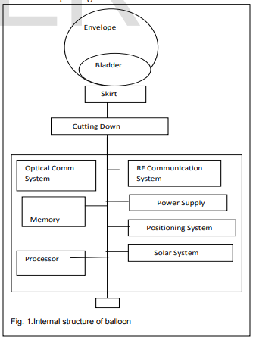

* The balloon envelope structure used in the project are made by Raven Aero star company, and are composed of polyethylene plastic about 3 mm or 0.076mm thick. These super pressure balloons are filled with helium. Stand almost 50ft across and 40ft tall when fully inflated carry a custom air pump system that pumps in or releases the air to stable the balloon and control its elevation. The envelop bag of balloons thickness is only thrice than a supermarket shop carrier bags but still capable to remain there at very high altitude at very high pressure without exploding.
* A small box of weight 10kg contains each balloon with electronic equipment that hangs underneath the loons balloons. That small box consist the various circuit board which control the radio antennae system, other system functions, and all networks rocket M2 to communicate with the other balloons as a Wi-Fi as a transceiver and with the antenna on the ground, and a battery to store power so balloons can operate during the time when light is not there. A customized Linux OS is also loaded on the processor chip to manage and transmitter network and positioning data. Each balloon is powered by an array of solar panels that sit between the envelope and the hardware. A parachute attached at the top of the envelope allows for a controlling of balloon and landing when a balloon ready to be taken out of service. In any case if there is an unexpected failure, the parachute gets deployed automatically.
* Three components are required for designing a Google Loon Balloon:

1. Envelope

2. Solar panels

3. Equipment

* Balloon’s electronic equipment is placed in a small box, it hangs underneath loon`s balloons, like the basket which is carried by a hot air balloon. That small box consist circuit board and it controls the system, radio antennas are used to communicate with the other loon`s balloons and with internet antenna on the ground, and loon`s batteries to store solar power.

**WORKING OF LOON TECHNOLOGY**

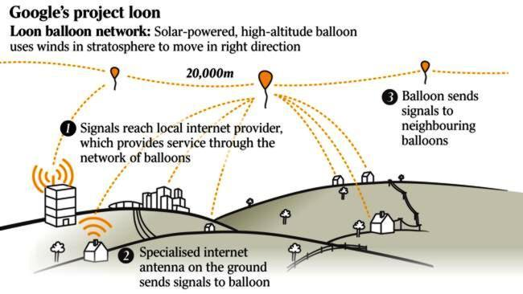

1. As A user with the specialized antennas sends signal via radio frequency over ISM bands to a balloon close to him.
2. The balloon sends the signal to the neighbouring balloons.
3. Eventually, the signals reach balloon which is connected to the local internet. The wireless mesh network is constantly adjusting as balloon move.
4. Any balloon is able to connect the internet to the base station which has internet connectivity and then receives internet data and forwards them via balloon in the sky to the destination.

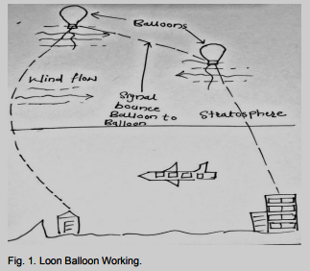

1. Finally, the balloon close to the request user broadcast the data to the ground via a radio frequency over ISM bands.
2. The special antenna installed the outside of home receives data and decrypt the data.
3. The wireless mesh network should be constantly adjusting the balloons move. It covers an area of an around 40km (28miles) diameter circle which is twice the area of New York City.
4. Thousands of balloons can cover the whole world.

**CONNECTIVITY BETWEEN BALLOON AND GROUND**

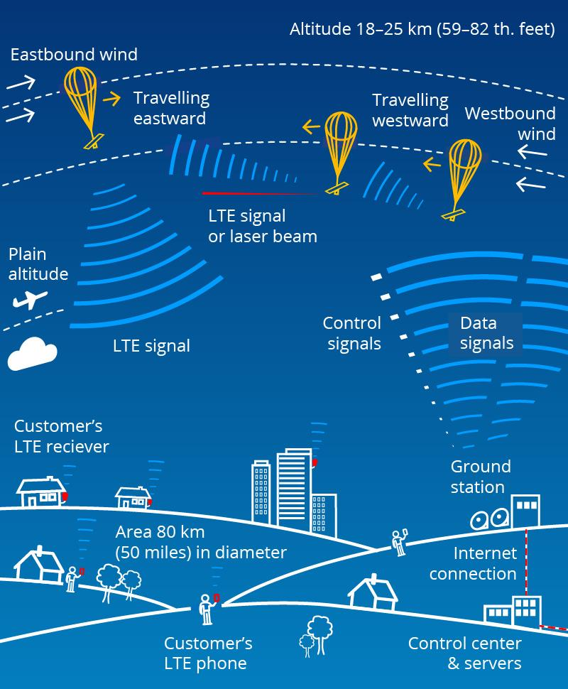

1. Each balloon can provide connectivity to a ground area about

40km in diameter at speed comparable to 3G.

1. Locations of balloons tracked with a GPS.
2. The radio transceivers were used for
3. Balloon to balloon communications.
4. Balloon to ground communication
5. Third for backup.
6. The balloon use antennas equipped with specialized radio frequency technology.

Several ground stations with transceivers similar to that on the balloon, but high powered ubiquity Rocket M5 (operating at 5.8 GHz). The network designed as mesh layout to ensure reliability. A ground station already connected via either Fiber or other backbone infrastructure to the internet, beams signals to any nearby balloon. The first balloon that receives the signal, then forwards or hops the signals up to 5 other balloons on its same path in sequence, a distance of about 100km (62 miles)

1. **Ground Stations:** These were located in various regions and connected to existing internet infrastructure.
2. **Balloon Network:** The balloons were strategically positioned in the stratosphere, creating a network that could cover large areas.
3. **Backhaul Connection:** The balloons were connected to ground stations via a backhaul link. This link was typically a radio frequency connection, allowing data to be transmitted between the balloons and the ground.
4. **User Connectivity:** Once a balloon was in range, users could connect to it using specialized antennas or devices, similar to connecting to a cellular network.

**AI’s ROLE IN PROJECT LOON**

* Artificial Intelligence (AI) began playing a significant role in Project Loon as early as 2017. This was when Alphabet's X division, responsible for Project Loon, started integrating AI-driven machine learning algorithms to enhance the project's efficiency and effectiveness.
* In particular, AI was used to improve the autonomous navigation of the balloons by predicting wind patterns and optimizing flight paths. By 2018, the use of AI had become central to managing the entire fleet of Loon balloons, enabling the system to adjust in real-time to changing conditions in the stratosphere and ensure consistent internet coverage.
* The integration of AI allowed Project Loon to operate with greater autonomy, reduce human intervention, and scale the project more effectively across different regions.

Here’s how AI was incorporated:

1. **Predicting Wind Patterns:**
   * **Machine Learning Models:** Advanced machine learning algorithms were used to analyse historical wind data and predict future patterns.
   * **Optimized Balloon Routing:** This information helped determine the most efficient paths for the balloons to follow, maximizing coverage and minimizing energy consumption.
2. **Managing Balloon Clusters:**
   * **AI-Driven Control Systems:** Intelligent systems were developed to manage clusters of balloons, ensuring they remained in the desired altitude range and provided optimal coverage.

**WORKING OF DRL THROUGH AN EXAMPLE**

**Deep Reinforcement Learning (DRL) for Navigating Stratospheric Balloons**

Deep reinforcement learning (DRL) is a type of machine learning and artificial intelligence that allows machines to learn from their actions, similar to how humans learn from experience.

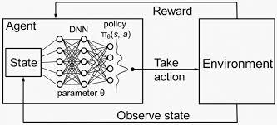

**Here's how the process works, as illustrated in the diagram:**

1. **State:** The balloon's current situation, including its altitude, latitude, longitude, wind speed, and direction.
2. **Agent:** The balloon itself, acting as an intelligent agent that makes decisions.
3. **Action:** The agent can take actions like adjusting its altitude, changing direction, or modifying its shape to influence its trajectory.
4. **Environment:** The stratosphere, with its unpredictable wind patterns and other factors.
5. **Reward:** The agent receives rewards based on its actions. For example, it might receive a positive reward for staying within a desired altitude range or a negative reward for drifting off course.
6. **Policy Network (DNN):** A deep neural network that takes the current state as input and outputs a probability distribution over possible actions.
7. **Take Action:** The agent selects an action based on the probability distribution from the policy network.
8. **Observe State:** The agent observes the new state and receives a reward from the environment.
9. **Update Policy:** The agent uses a DRL algorithm, like Deep Q-Networks (DQN) or Proximal Policy Optimization (PPO), to update the parameters of its policy network based on the experience it has gained.

**Key Points:**

* **Deep Neural Network:** The policy network is a deep neural network that learns to map states to actions.
* **Trial and Error:** The agent learns by trying different actions and observing the consequences.
* **Optimization:** The goal is to optimize the agent's policy so that it takes actions that maximize the cumulative reward over time.

**ADVANTAGES OF PROJECT LOON**

**1. Global Coverage:**

* **Remote Areas:** Balloons could reach areas with limited or no existing internet infrastructure, such as rural areas, developing countries, and disaster zones.
* **Accessibility:** This would provide millions of people with access to information, education, and economic opportunities.

**2. Rapid Deployment:**

* **Scalability:** Balloons could be quickly deployed to areas in need, providing temporary or long-term internet connectivity.
* **Disaster Response:** This would be particularly valuable in the aftermath of natural disasters or conflicts.

**3. Cost-Effective:**

* **Infrastructure:** Balloons are relatively inexpensive to manufacture and operate compared to traditional infrastructure like fiber-optic cables or satellites.
* **Accessibility:** This could make internet access more affordable for people in remote areas.

**4. Flexibility:**

* **Adaptability:** Balloons could be moved to different locations based on changing needs or weather conditions.
* **Resilience:** This would make the network more resilient to disruptions.

**5. Wide Coverage:** The network of balloons could cover large areas, even in regions

where traditional infrastructure is difficult or impossible to build.

**LIMITATIONS OF PROJECT LOON**

**1. Weather-Dependent:**

* **Wind Patterns:** The balloons were highly dependent on wind patterns, which could limit their manoeuvrability and coverage.
* **Storms:** Severe weather conditions could damage or destroy balloons, impacting service reliability.

**2. Cost and Scalability:**

* **Infrastructure:** Maintaining a large fleet of balloons required significant infrastructure and resources.
* **Economic Viability:** It was uncertain whether the project could achieve a sustainable business model.

**3. Altitude Constraints:**

* **Solar Radiation:** The high altitude of the balloons exposed them to intense solar radiation, which could shorten their lifespan.
* **Atmospheric Conditions:** The stratosphere, where the balloons operated, presented challenges for maintaining stable flight and communication.

**4. Regulatory Hurdles:** Obtaining regulatory approval for balloon operations in

different countries was a complex and time-consuming process. Governments

often had concerns about potential interference with existing communication

systems, national security, and airspace management.

**FUTURE SCOPE OF PROJECT LOON**

**1. Advanced Materials and Structures:**

* **Lightweight Materials:** Research into lighter, stronger materials could improve the efficiency and longevity of balloons.
* **Adaptive Structures:** Developing structures that can adapt to changing environmental conditions could enhance the balloons' resilience.

**2. Improved Communication Technologies:**

* **Laser Communication:** Exploring the use of laser communication could enable higher data transfer rates and reduce interference.
* **Advanced Antennas:** Developing more efficient antennas could improve the balloons' communication capabilities

**3. Autonomous Navigation and Control:**

* **AI and Machine Learning:** Enhancing AI and machine learning algorithms could enable balloons to navigate more autonomously and efficiently.
* **Collision Avoidance:** Developing advanced collision avoidance systems.

**4. Integration with Other Technologies:**

* **Satellite Communication:** Combining balloon-based connectivity with satellite networks to provide more robust and reliable coverage, especially in remote areas.
* **Ground-Based Infrastructure:** Integrating balloons with ground-based infrastructure, such as cellular towers, to create a hybrid network that leverages the strengths of both technologies.

**CONCLUSION**

Project Loon, while ultimately discontinued, serves as a valuable proof of concept for the potential of using high-altitude balloons to provide internet connectivity to remote areas. despite its challenges, the project demonstrated the feasibility of such a technology and paved the way for future research and development. Project Loon continues its research and development phase, its future remains promising.The technology has proven its potential but faces hurdles that need to be addressed for broader implementation .Continued research and experimentation will be essential to fulfill its goal of providing global internet coverage .

**REFERENCES**

[1] [N. V. Kadam, A. G. Kadu, and S. S. Dhok, "Internet Through Balloons – A Study," Volume 7, Issue 2, February-2016 ISSN 2229-5518](https://www.ijser.org/researchpaper/Internet-Through-Balloons-A-Study.pdf)

[2] Google Project Loon,<https://x.company/projects/loon/>

[3] [Google Project Loon, YouTube](https://youtu.be/jjSV_UAaO4I?si=4WOGKdvBGTp4j6VT)

[4] Loon LLC, Wikipedia,<https://en.wikipedia.org/wiki/Loon_LLC>

[5] [S. Katikala, "GOOGLE™ PROJECT LOON," InSight: RIVIER ACADEMIC JOURNAL, VOLUME 10, NUMBER 2, FALL 2014](https://www2.rivier.edu/journal/ROAJ-Fall-2014/J855-Katikala_Project-Loon.pdf)